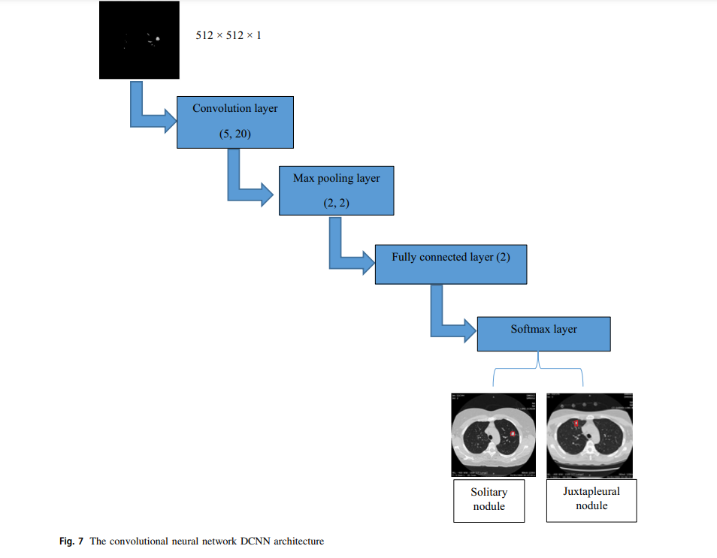

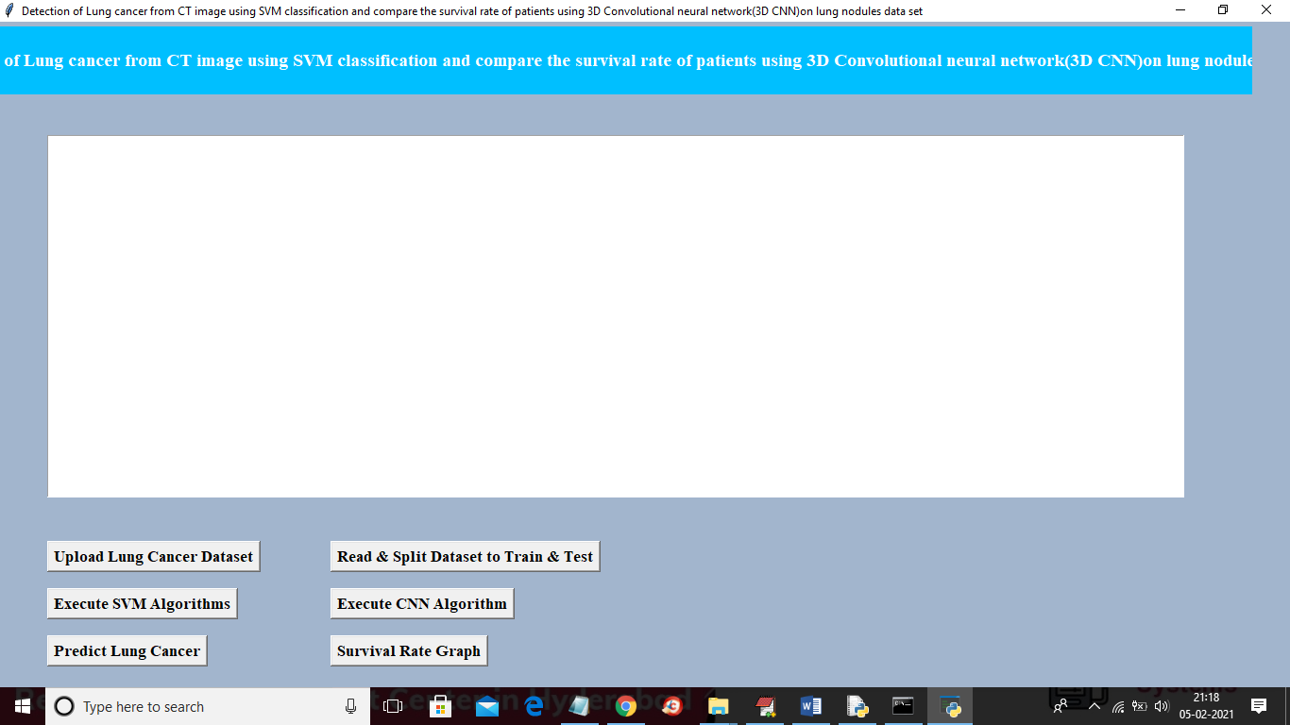

Code

from tkinter import messagebox

from tkinter import *

from tkinter import simpledialog

import tkinter

from tkinter import filedialog

import matplotlib.pyplot as plt

import numpy as np

from tkinter.filedialog import askopenfilename

import pandas as pd

import os

import cv2

import numpy as np

from sklearn import svm

from sklearn.metrics import accuracy_score

from sklearn.model_selection import train_test_split

from sklearn.decomposition import PCA

from keras.utils.np_utils import to_categorical

from keras.layers import MaxPooling2D

from keras.layers import Dense, Dropout, Activation, Flatten

from keras.layers import Convolution2D

from keras.models import Sequential

main = tkinter.Tk()

main.title("Prediction of time-to-event outcomes in diagnosing lung cancer based on SVM and compare the accuracy of predicted outcome with Deep CNN algorithm")

main.geometry("1300x1200")

global filename

global classifier

global svm_acc, cnn_acc

global X, Y

global X_train, X_test, y_train, y_test

global pca

def uploadDataset():

global filename

filename = filedialog.askdirectory(initialdir=".")

text.delete('1.0', END)

text.insert(END,filename+" loaded\n");

def splitDataset():

global X, Y

global X_train, X_test, y_train, y_test

global pca

text.delete('1.0', END)

X = np.load('features/X.txt.npy')

Y = np.load('features/Y.txt.npy')

X = np.reshape(X, (X.shape[0],(X.shape[1]*X.shape[2]*X.shape[3])))

pca = PCA(n_components = 100)

X = pca.fit_transform(X)

print(X.shape)

X_train, X_test, y_train, y_test = train_test_split(X, Y, test_size=0.2)

text.insert(END,"Total CT Scan Images Found in dataset : "+str(len(X))+"\n")

text.insert(END,"Train split dataset to 80% : "+str(len(X_train))+"\n")

text.insert(END,"Test split dataset to 20% : "+str(len(X_test))+"\n")